Non-Agricultural Enterprises Analysis

1. Project Overview
- This Project involves in analysis of the Urban vs Rural development in India on the basis of Enterprises type other than agriculture using Excel and Power-BI.
- The analysis focus on the Enterprises type of MSME (Micro, small, mini enterprises) and non-MSME, gender wise employees of the enterprises, the community wise enterprises, salary of the Employee working the enterprises, Government act opted by the Enterprises, gross value added (gva) which is individual and enterprises contribution to Indian economy, propriety (ownership) of the enterprises.
Project Objective
The main objective is to demonstrate and visualize the Enterprises type, employee of the enterprises based on sector and state to the Urban and Rural development in India based on the 2016 Enterprises report.

2. Data Sources
- Source Description: Indiadataportal.com
- Source link: IDP | Non-Agricultural Enterprise Analysis
- Timeline: 2016
- Domain: Enterprises
3. Problem Statement
- To analysis the different types and activities of Enterprises other than agriculture in India based on sector and state wise using Power-BI charts to improve the enterprise count.
- To Visualise the sum of MSME (micro, small, mini, enterprises) and non-MSME using Power-BI cards to develop the MSME enterprise count in India.
- To analyse the salary and working hours of the employee in the enterprises on state, sector and gender basis to increase the individual salary range based on Indian economy.
- To demonstrate the range of government act opted by the different enterprises type and their activities to make all the enterprises to use the government act and introduce the new government act.
- To analysis the GVA (gross value added) by the Individual and Enterprises to develop Indian economy.
- To Visualise the sum of proprietary(ownership) of the enterprises using Power-BI cards on sector and state basis to develop the enterprise range.

4. Attribute (Column /Features) Details
Attribute Name | Data Type | Description
ID | Integer / String | Unique identifier for each employee
State name | String (Text) | Name of the state
State code | Numeric (Integer) | Code of the state
sector | Categorical | area wise of the enterprise
MSME | String (Text) | Micro small medium enterprise type
gva | String (Text) | Gross value added
hh | String (Text) | Enterprises based on partnership
propriety | String (Text) | Ownership of the Enterprises

5. Tools & Technologies
- Excel: Data cleaning, transformation, and Pivot Tables.
- Power BI: Data modelling, DAX calculations, visualization, and interactive dashboard creation.

6. Data Pre-Processing (Excel / Power Query)
Tasks Performed:
- Data Cleaning & Transformation: Removed duplicates in the ID filed to make the Enterprises data as unique and not to repeat the same data.
- handled missing numeric values by 0 and standardized formats by proper text cases.
- Filtering & Sorting: Organized and separate data as table in different sheets to understand the relevant records.
- Convert the data into Fact and Dimension Table using the ID column
- Data Model: Created the relationship between the tables using foreign and primary key with ID as a unique value.
- Pivot Tables: Generated Pivot Tables for some of the major tables.

7. Data Modelling and DAX (Power BI)
Data_ Model: created the new column using DAX query to find the below

Total = Table10[perennial (all 360 working enterprises)] +Table10[seasonal]

Total_gva = Gross_value_added_Data[avg_gv_4to8hr(working hours)]+Gross_value_added_Data[avg_gva_above8hr(working hours)]+Gross_value_added_Data[avg_gva_lessthan4hr(working hours)]+Gross_value_added_Data[fixed]+Gross_value_added_Data[gross_value_added]+Gross_value_added_Data[per_employee_gva]+Gross_value_added_Data[per_enterprise_gva]+Gross_value_added_Data[total_outsidehh(partnership)]+Gross_value_added_Data[within_hh(partneership)]

Total act = act_data[establishment_act]+act_data[local_body]+act_data[sales_tax_act]+act_data[provident_fund_act]+act_data[esc_act]+act_data[stock_exchange]+act_data[other_industry_act]

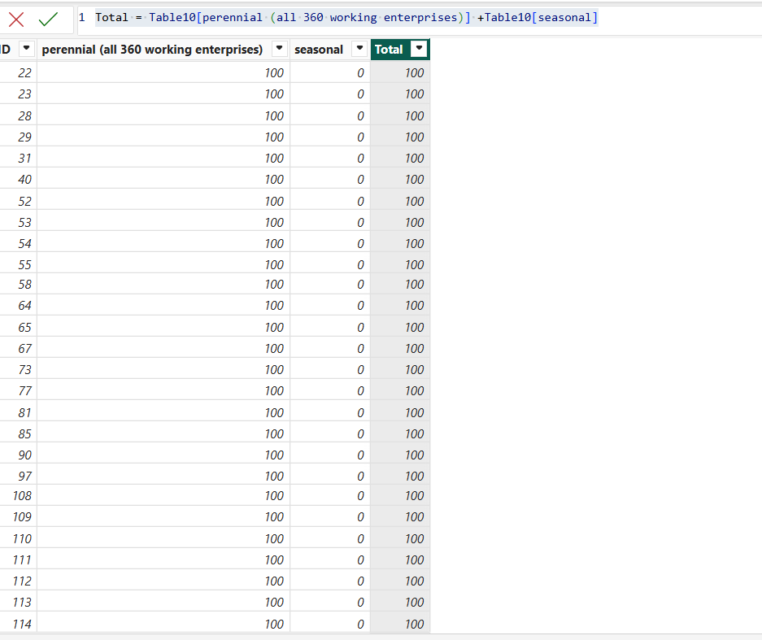

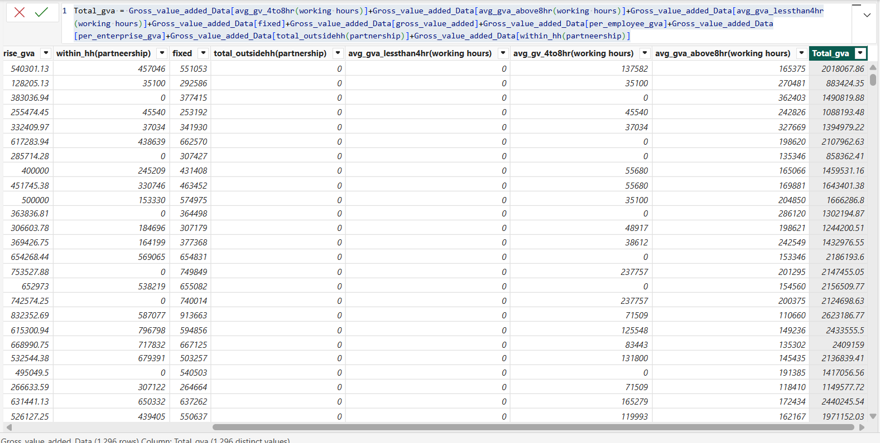

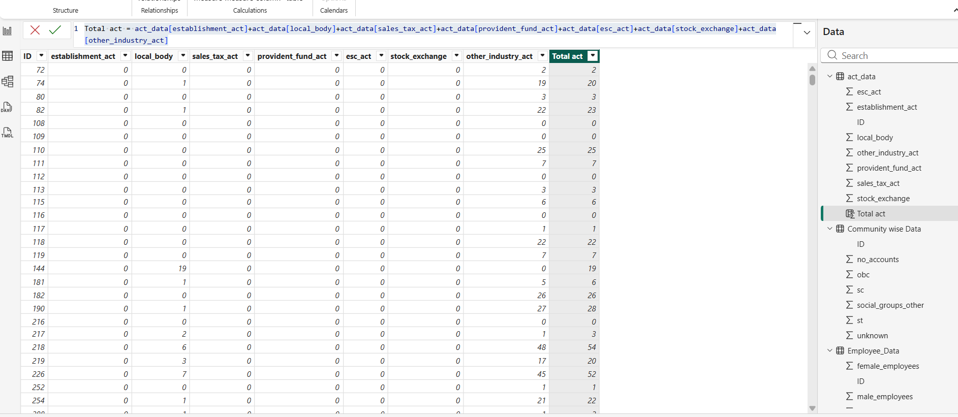

DATAMODEL: Created relationship between tables
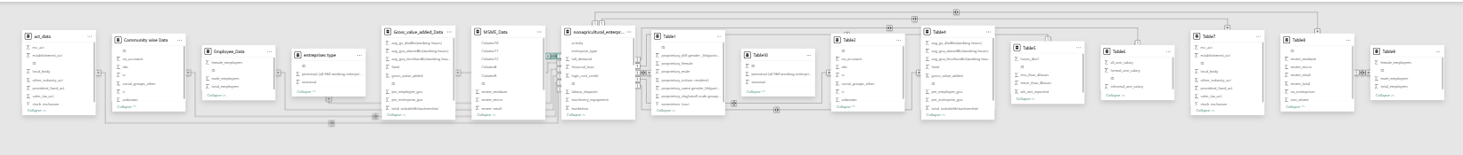
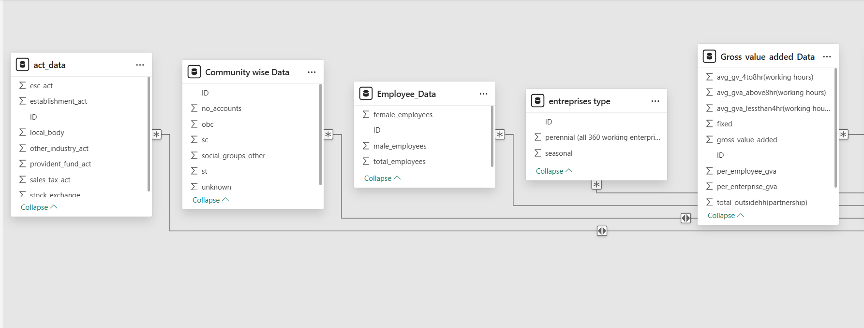

8. Analysis and Visualizations (Power BI)
- The Map shows the activity like “Manufacturing”, “Trade”, “services” and “all 3” on state wise.
- The Bar chart shows the count of activity by state and sector.
- Sum of MSME and non-MSME enterprises using cards.
- The Stacked bar chart shows the employee working hours based on gender on state and sector wise.
- The Stacked bar chart explains the sum of the act on sector wise.
- The Pie-chart defines proprietary based on state and sector.
- Line chart shows the gva (gross value added) of Individual and enterprises based on state.
- Line chart explains the utilisation of act on state wise.
- Mutli row card defines the sum of community wise Enterprises.

9. Insights
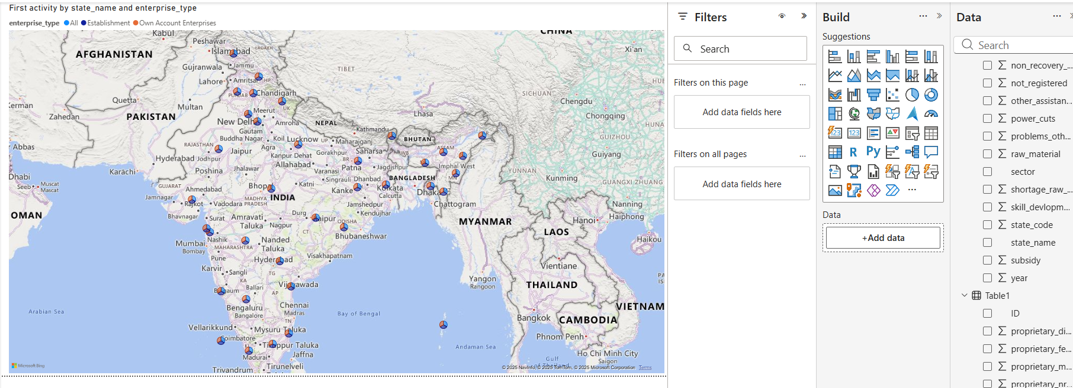

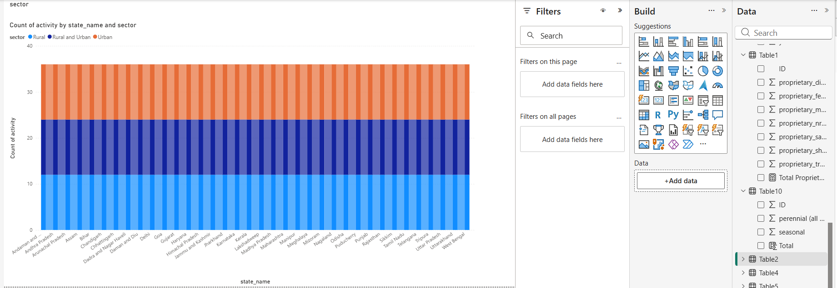

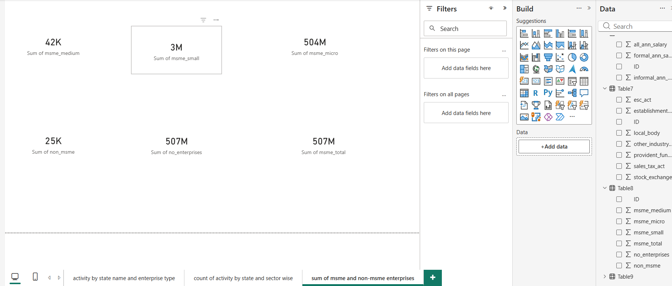

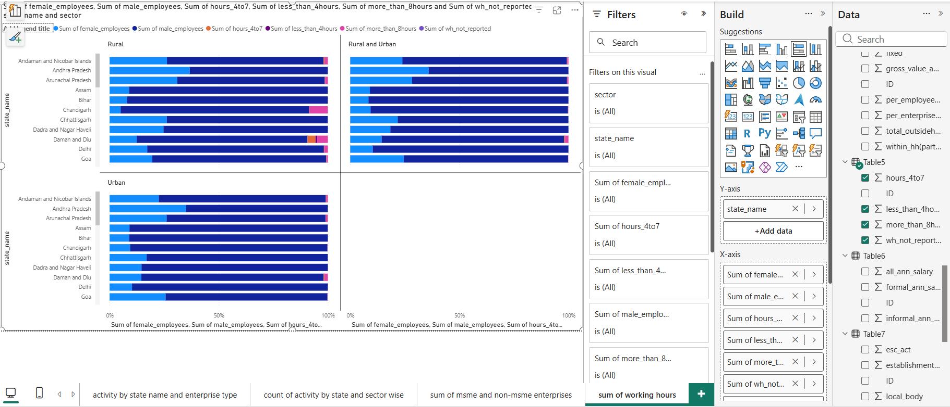

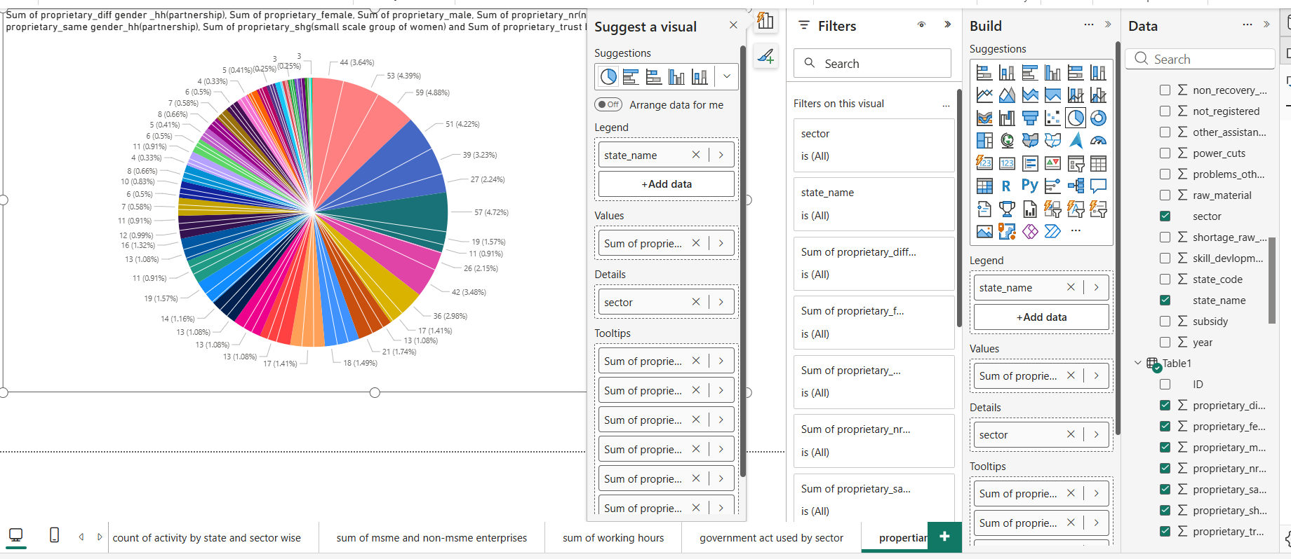

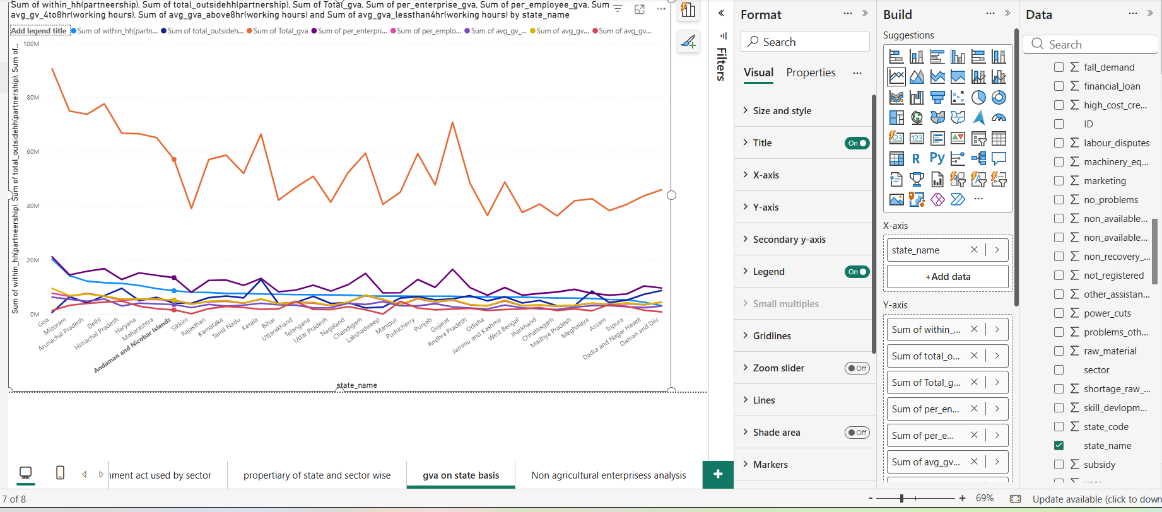

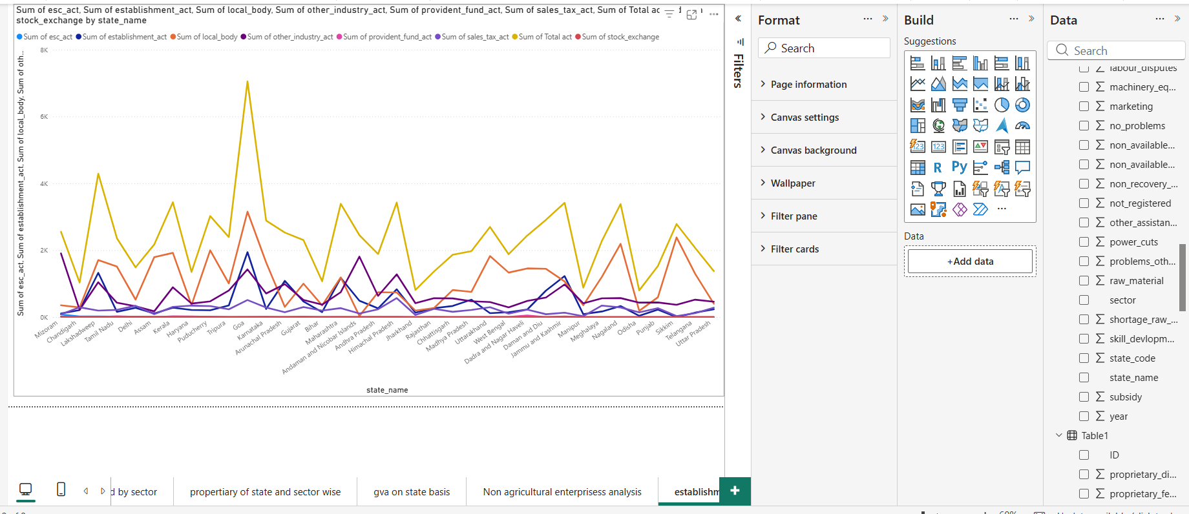

DASHBOARD OF Non-Agricultural Enterprises Analysis
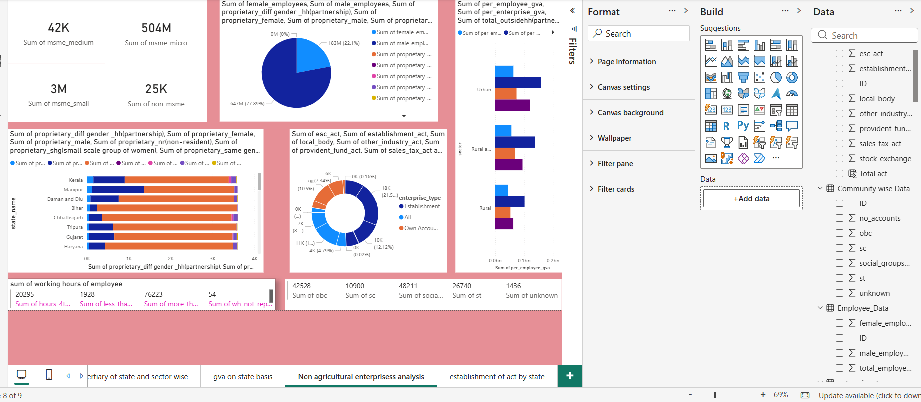
- Key Findings:
  - Goa has the highest gva (gross value added) and Sikkim has the lowest gva to Indian Economy towards non-agricultural Enterprises in the year of 2016.
  - Male has the major propriety ownership when compared to female, “partnership of same gender” and “partnership of different gender” at India in the year of 2016
  - Kerala state in Urban sector (4.88%) has major propriety ownership when compared to Rural (3.64) and urban and rural combined (4.39 %) sector towards India.
  - Micro MSME (504 M) count is greater than small MSME (3 M), Medium MSME (42 k) and non MSME (25k).
  - Employee working more than 8 hours (76223) are highest in India when compared to employee working 4 to 7 (20295) hrs, less than 4 hrs (1928) and not reported (54).
  - Local body act (21.57 %) is mostly utilised by many Enterprises compared to other act.
  - Goa has placed the first place and Jharkhand placed last to utilise the more government act of India.
  - Community of social groups has the more enterprises when compare to SC, ST, OBC, Unknown.

- The analysis insights:

    - Descriptive analysis:
Male employee has more propriety ownership when compared to female, “partnership of same gender” and “partnership of different gender” at India. Urban sector has the major Enterprise in India when compared Rural and Urban Rural. Social groups have more enterprises when compared to other groups. Goa used the major Government act hence placed the first place in gva (gross value added) to Indian economy and Employee worked more than 8hrs are highest ration in India.

    - Diagnosis analysis:
As the analysis of 2016 non-agricultural Enterprises report the government act was not mostly used by the Enterprises in the Rural and “Urban and Rural “combined sector Urban sector has more proprietary (ownership) which results the less contribution that is gva to the Indian economy.
- Predictive anslysis:
Kerala has major propriety ownership in Urban sector when compared to Goa, hence if Kerala increases the uses of government of act in Enterprises and propriety ownership is high by men if women contribute more propriety ownership in Enterprises, then Kerala will become the first to contribute more in gva to Indian economy.
- Prescriptive analysis:
- As the result of analysis Sikkim has contribute lowest gva to Indian economy hence to improve the gva the Sikkim has to utilise the more government act in enterprise.
- The Range of Women propriety has to increase to improve the Rural based enterprises.
- The Employee working in 4 to 7 hours and less than 4hrs has to increase their working hours to develop the individual gva contribution to Indian economy.

10. Conclusions
This analysis demonstrates the Urban vs Rural based enterprises other than agriculture on state and sector basis. The Power BI dashboard shows the sum of MSME (micro, small, minimum enterprises) and non MSME, sum of community wise enterprises, gva, propriety and government act on state wise, employee working hours in the enterprises to improve the Rural based enterprises and to improve the women propriety (ownership of the enterprises) in India.

